# Atlas Copco Quotation System

# *QuickQuote*

**Instructions and Tutorial**

System requirements 2

Using Internet Explorer (IE) 2

Installation 2

Overview 3

Detailed function description 4

Information input – Basic information 4

Cover Letters, Note, and Terms and Conditions 4

Product Description and Technical Specifications 5

Selecting products 6

Get PDF 7

# System requirements

The application is written in HTML, CSS and JavaScript. It is run as a normal web page in a web browser, making the system platform independent. It has been tested to work with Google Chrome v28, Firefox v22 and Internet Explorer 9 and 10 web browsers.

## Using Internet Explorer (IE)

If you try to run the application in Internet Explorer please make sure that you have IE 9 or newer as it is not compatible with IE 8 or earlier.

**Note!** You also have to allow the script by clicking “Allow Blocked Content” when asked (at the bottom of the screen).

To check what version of IE click preferences “about Internet Explorer” or visit:

<http://windows.microsoft.com/en-us/internet-explorer/which-version-am-i-using>

To be able to generate a PDF you need to install a PDF converter to IE. Please ask your IT-support for suggested software.

# Installation

To install the application, simply extract the zipped folder to your local file directory. It is important to make sure that the folder is **unzipped** as it cannot run directly from the zipped folder.

To run the application just click the index.html file to open it in your web browser. If you wish to open it in a browser that is not the system standard, right-click and choose “Open with…”

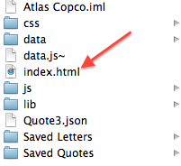

# Overview

The application is divided into three sub pages: “Information Input”, “Products” and “Quotation”.

Macintosh HD:Users:eriksparre:Desktop:Screen Shot 2013-07-31 at 11.16.54.png

Information Input and Products are pages for input and the quotation will be generated on the Quotation page. All changes to the quote have to be made on the input pages, except for adjusting the quantity of the quoted products. You can go back and forth between the pages without having to save any data, and the Quotation view will populate automatically.

Whenever you close down the browser or refresh the page the current information entered will be lost and you have to save the quote in order to retrieve it at a later point. This may to done with the **save** button in the top right.

To **load** a file just choose the file from your local system by clicking “browse” in Internet Explorer or “Choose file” in Google Chrome. Then click the load button to load the quote into the application.

To get a PDF output either use a PDF-converter plugin for Internet Explorer of the built in function in Google Chrome.

# Detailed function description

## Information input – Basic information

Basic information will appear on the front page and in the address field of the cover letter. On the front-page customer first and last name will be used and on the cover letter the title and the last name will be used.

If you choose to include the date it will be printed on the front-page and on the first page of the cover letter.

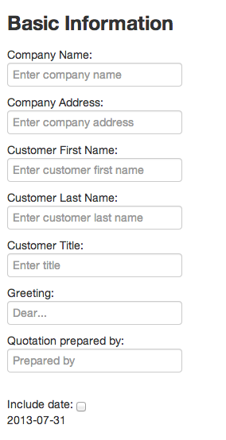

## Cover Letters, Note, and Terms and Conditions

To make a cover letter you have to following options:

1. Write one from scratch in the textbox provided
2. Choose from a selection of standard letters in the dropdown menu
3. Import a saved letter from a .txt file

To import a letter from a saved file, first select the file by using the file selector (“Browse” in IE, “Choose file” in Chrome). After a letter is selected please click “load” to load in the content to the textbox. The letter can now be edited and saved.

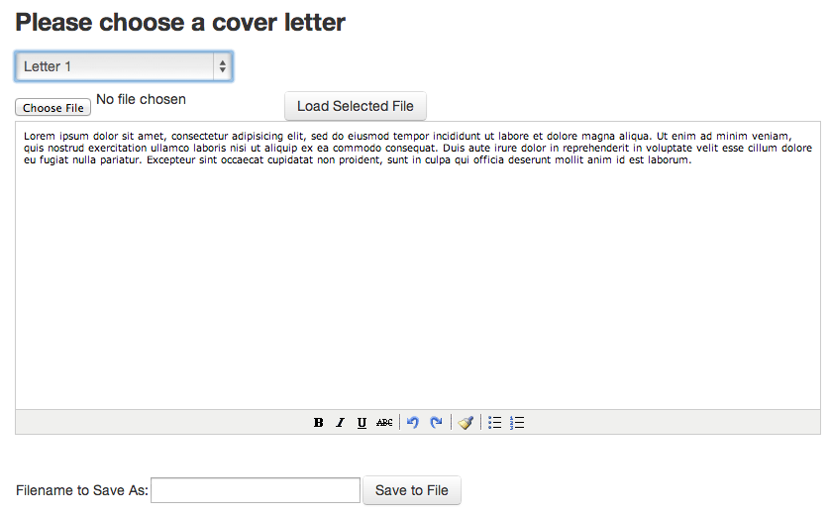

To save a letter, write the desired file name in the “Filename to Save As” box and then click “Save to File” button. The browser will now download the letter to your default download folder. To change download location in IE you may choose “Save As” when the file saving dialog pops up. In the project folder there is a folder called “Saved Letter” for your convenience.

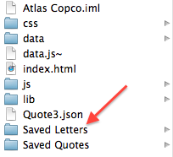

To load a preconfigured note follow the same instruction as for the cover letter.

To populate the Terms and Conditions please select one option from the dropdown menu.

## Product Description and Technical Specifications

Simple tick the checkbox next to the product description or technical specification you would like to include in the quote.

## Selecting products

There are two ways of adding products to the quote:

1. Using the dropdown menu with associated radio and checkboxes
2. Custom adding products from a list

The first method will make sure that only products compatible with the base product will be selected and will filter out all irrelevant choices. In order to add products using this method, first select a base from the dropdown menu. After the base is selected you may make the necessary configurations among the categories that pops up. When the choices have been made you may add this to either the first price summary or the second price summary by clicking the corresponding buttons (see picture).

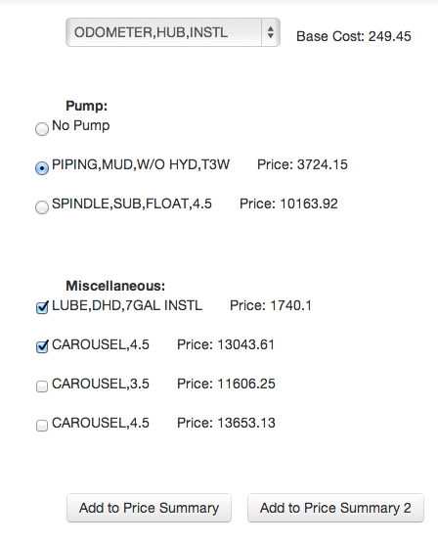

**Discount** may be added to either of the price summaries.

The user **shall** specify **a currency** in the currency field. This will appear on the quotation view.

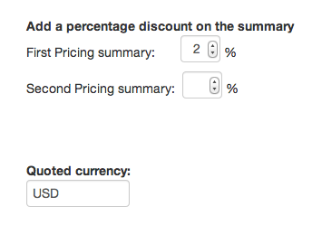

The **price** of the individual products may be changed in the price summary matrix. This will only change the price of the particular product for this quote and for future quotes.

To **remove** a product simply click the “-“ button to the right

To **sort** the product according to “Part number”, “Description” or “Cost” just click the blue headlines

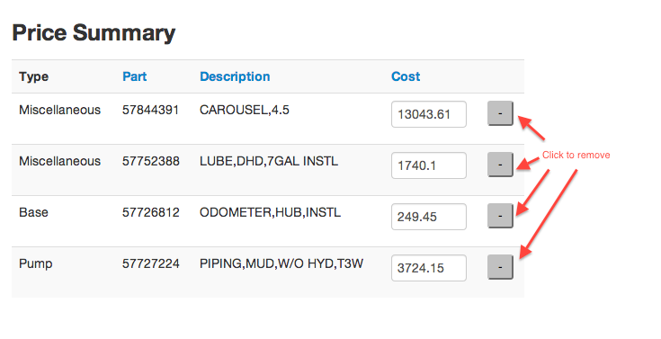

To **search** among all the products, you may use the search function at the bottom of the page. To add a particular product to either price summary, simply click “Add First” or “Add Second” button.

## Get PDF

To make a PDF in Chrome, just press ctrl+p and choose “Save as PDF”. In IE, just press ctrl+p and choose your PDF writer.

For any questions and support, please contact:

xxxx